Guppy Reinvented MTF

It is not really MTF.

I have introduced H1 and H4 histogram on M15

H4 histogram on H1.

These histograms represent Gann 9 activator of the respective timeframes.

This is mainly for traders who like to look at higher time frame charts for trade entries in lower timeframe. I do not recommend trading below M15 timeframe.

For H4 and above the trend is already well established and no need to refer to higher timeframes for trend direction.

**Enter trade when all indicators are of the same color.**

M15 Chart:

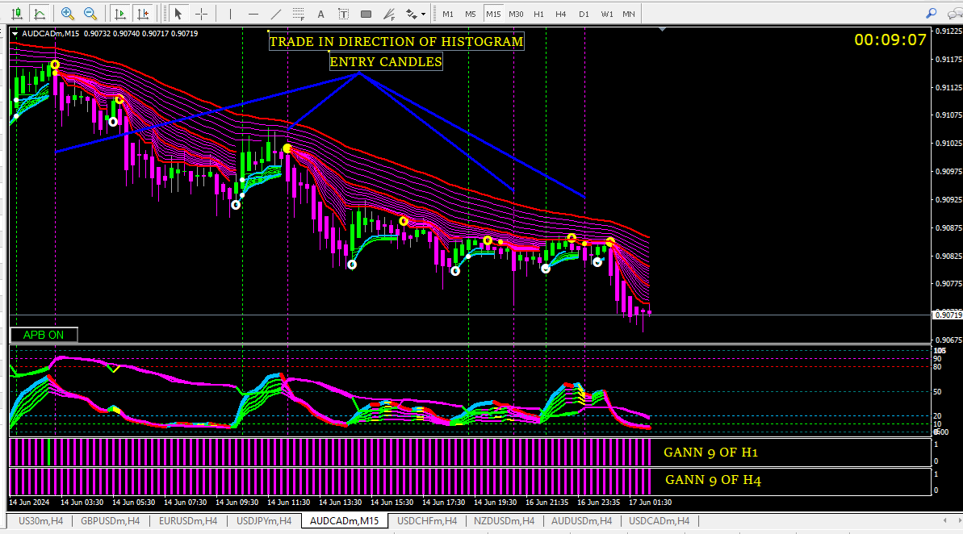

H1 CHART

